Drake Orthodontics

Cleaning and Eating Instructions
Thank you for choosing Drake Orthodontics! To maintain healthy teeth and gums while wearing braces, please follow these instructions:
- The best preventative measure is excellent oral hygiene. This includes brushing with fluoridated toothpaste for at least three minutes, three times daily. An electric toothbrush is highly encouraged. After brushing, look at your braces closely in the mirror to make sure all food debris and plaque were removed. Next, you are expected to floss at least once daily. For most people this is during the evening time, because that is when they have enough time to do so. Lastly, swish for a minimum of 30 seconds with Crest Pro-Health mouth rinse twice daily. We recommend the Crest Pro Health mouth rinse due to its fluoride content and antibacterial benefits.

- Fluoride is a very important part of the prevention process. The daily fluoride received in your toothpaste and mouth rinse will help prevent cavities and white scars from forming on your teeth.

- Minimize foods or drinks that are high in sugar. Consuming these increase the chance of cavities, white scars, and gum disease. If you choose to eat or drink these foods, please do so in a limited fashion to reduce exposure time and make an effort to brush immediately afterwards!

- Please eat hard foods carefully, as they may break your braces. This means cutting up hard foods into bite size pieces that can be chewed with back teeth. Broken brackets or bent wires can be repaired, but it may result in more appointments and/or an increase in total treatment time. It is best to prevent this! Sticky foods should be avoided too, as they will stick to your braces and could pull them off. Please brush immediately following your meals!

- Please call us if anything becomes loose or broken (309-808-0054). This allows us to schedule enough time to fix the problem at your next appointment. Thanks!

The rewards of braces - straight teeth, a beautiful smile, and a healthy mouth – are achievable goals for all of our patients. We need your help to make sure your teeth and gums are bright, shiny, and healthy at the completion of treatment!
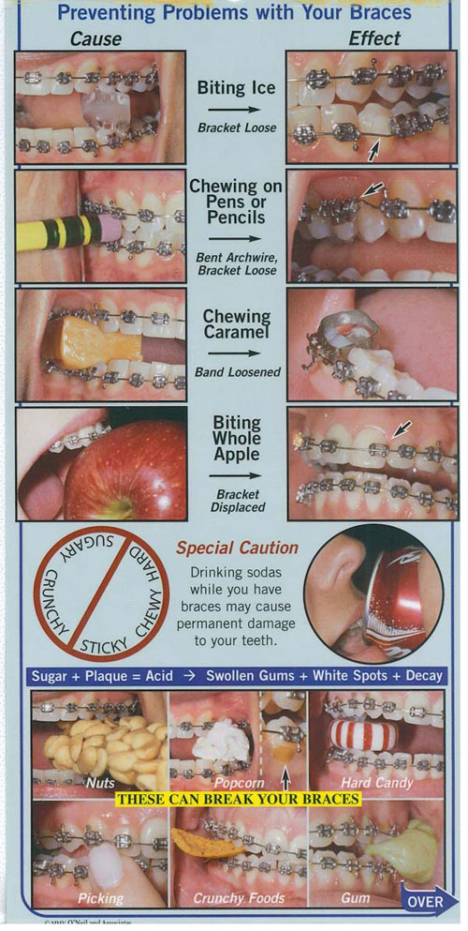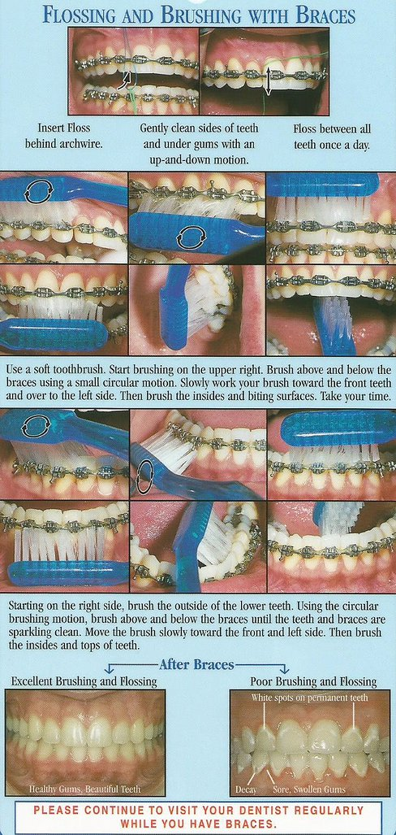

Drake Dollars
Our practice has an incentive program for our patients. Our goal is to ensure that you keep on track with your treatment by encouraging great cooperation, enthusiasm and having fun! You can earn “Drake Dollars” at your regular scheduled appointments by doing the following:
Earn 1 “Drake Dollar” by:
- Awesome hygiene - $1
- Nothing loose or broken - $1
- Arrive on time - $1
- Wear your rubber bands and appliance as recommended - $1
- Wear your Drake Orthodontic t-shirt to your appointment - $1

Earn extra “Drake Dollars” by:
- Refer family or friends to us as a new patient - $10
- Friend us on Facebook - $1
- Check in on Facebook -$1
- Tag us in a photo on Facebook - $1
- Share 1 of our posts on your Facebook page - $5
- Comment under a post on our Facebook page - $2
- For every “A” on your report card. Report card must be present. $1 for every “A”
- Give us a positive review on Facebook, Google and Bing - $5

Drake Dollars will not be given for emergency appointments or retainer visits

